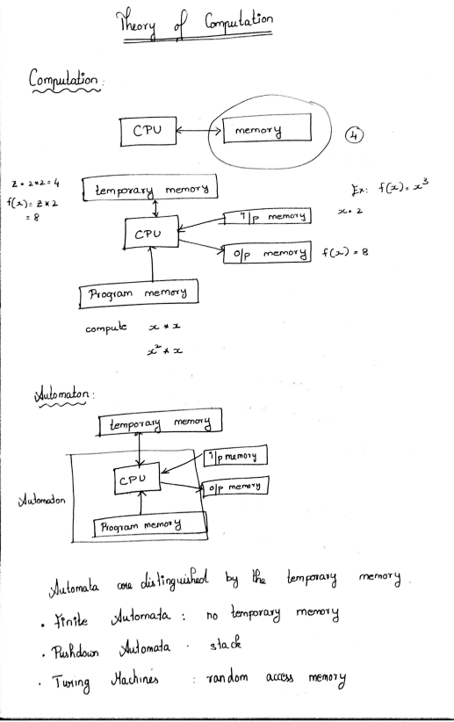Scanned by CamScanner
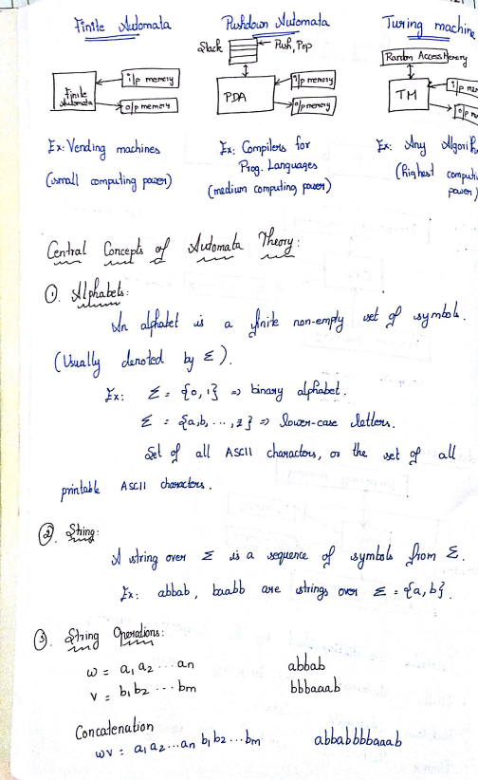Scanned by CamScanner
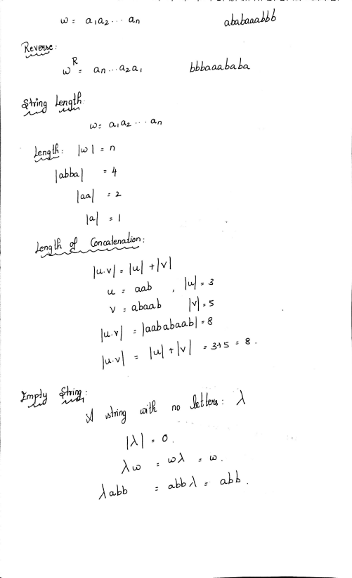Scanned by CamScanner
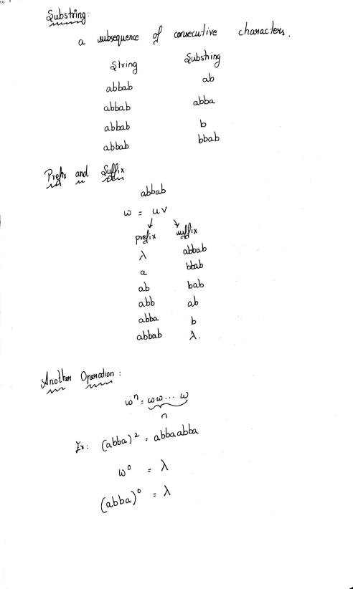Scanned by CamScanner
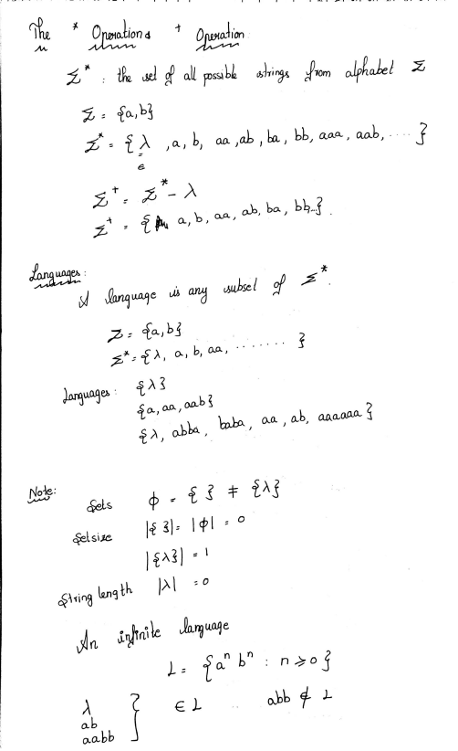Scanned by CamScanner
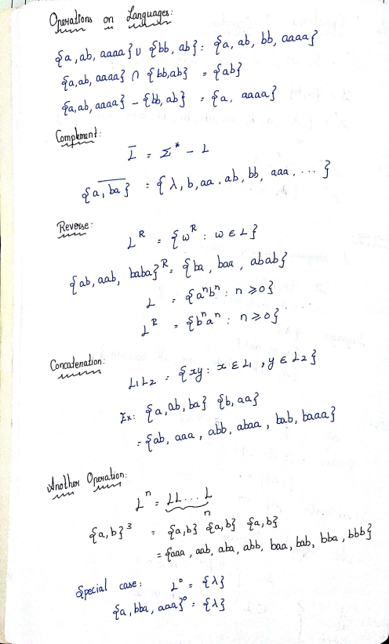Scanned by CamScanner
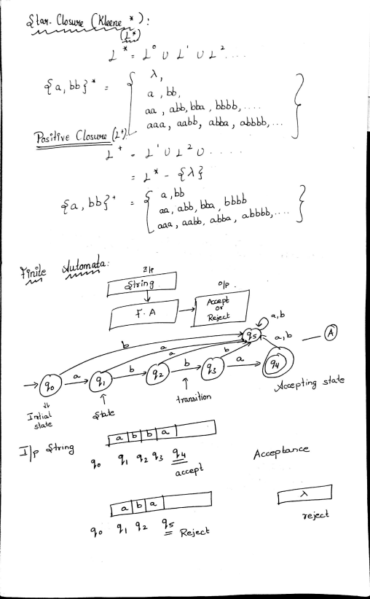Scanned by CamScanner
Scanned by CamScanner
Scanned by CamScanner
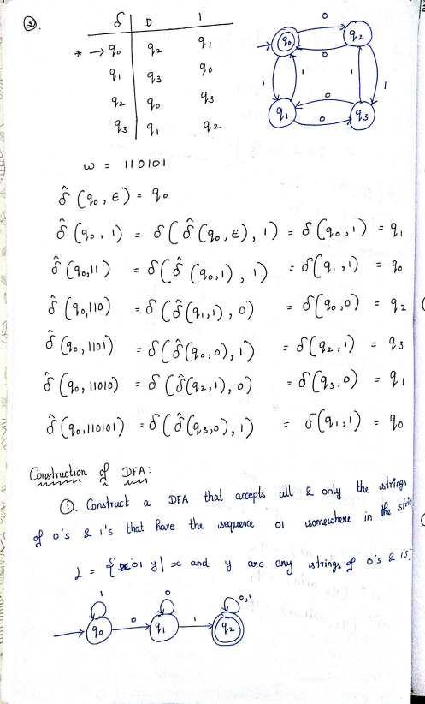Scanned by CamScanner
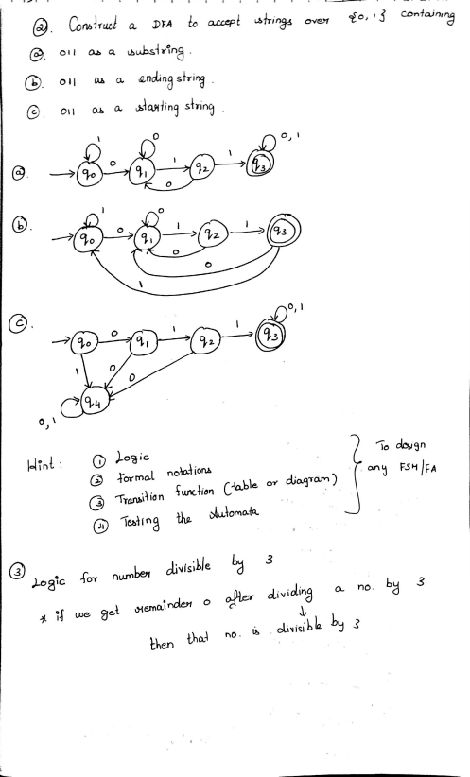Scanned by CamScanner
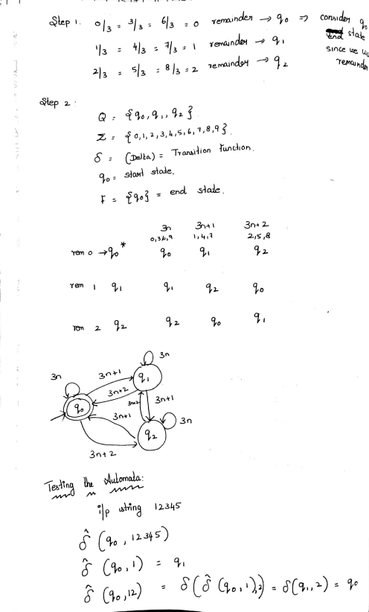Scanned by CamScanner
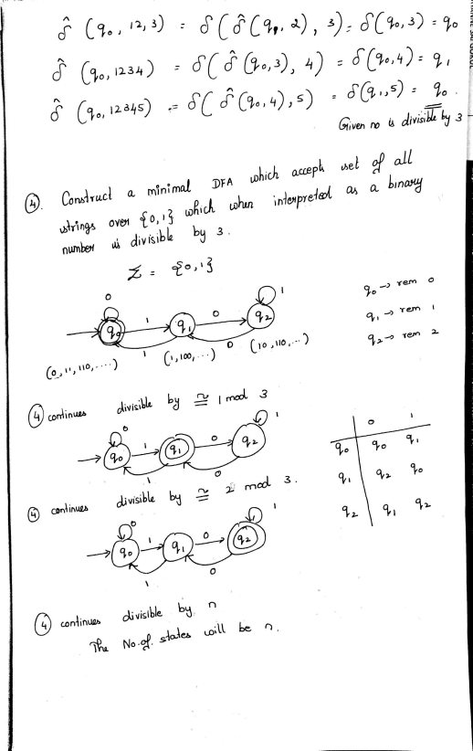Scanned by CamScanner
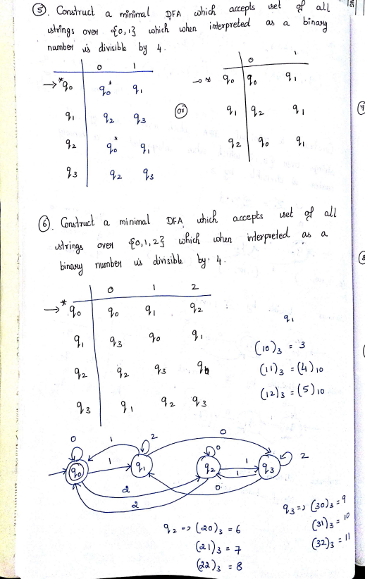Scanned by CamScanner
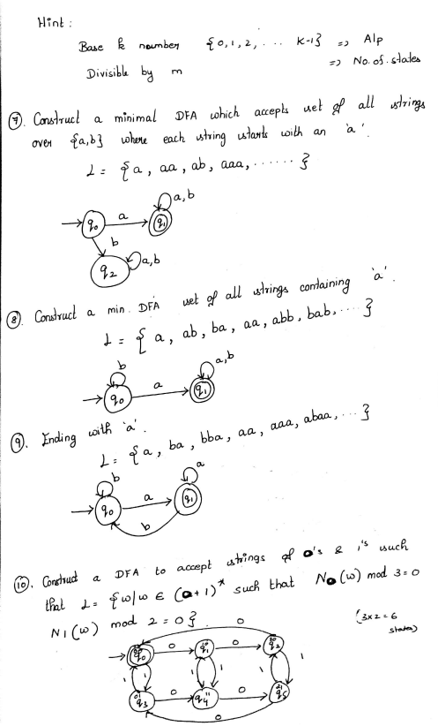Scanned by CamScanner
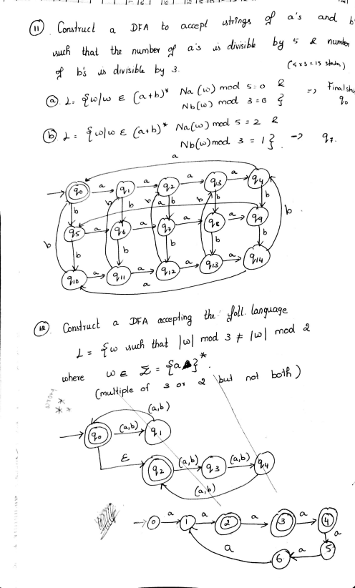Scanned by CamScanner
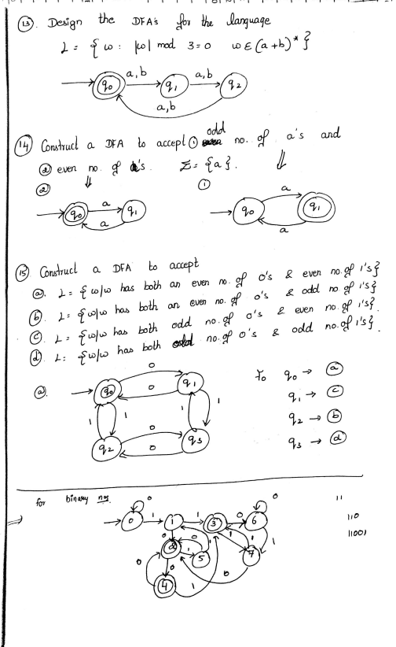Scanned by CamScanner
Scanned by CamScanner
Scanned by CamScanner
Scanned by CamScanner
Scanned by CamScanner
Scanned by CamScanner
Scanned by CamScanner
Scanned by CamScanner
Scanned by CamScanner
Scanned by CamScanner
Scanned by CamScanner
Scanned by CamScanner
Scanned by CamScanner
Scanned by CamScanner
Scanned by CamScanner
Scanned by CamScanner
Scanned by CamScanner
Scanned by CamScanner
Scanned by CamScanner
Scanned by CamScanner
Scanned by CamScanner
Scanned by CamScanner
Scanned by CamScanner
Scanned by CamScanner
Scanned by CamScanner
Scanned by CamScanner
Scanned by CamScanner
Scanned by CamScanner
Scanned by CamScanner
Scanned by CamScanner
Scanned by CamScanner
Scanned by CamScanner
Scanned by CamScanner
Scanned by CamScanner
Scanned by CamScanner
Scanned by CamScanner
Scanned by CamScanner
Scanned by CamScanner
Scanned by CamScanner
Scanned by CamScanner
Scanned by CamScanner
Scanned by CamScanner
Scanned by CamScanner
Scanned by CamScanner
Scanned by CamScanner
Scanned by CamScanner
Scanned by CamScanner
Scanned by CamScanner
Scanned by CamScanner
Scanned by CamScanner
Scanned by CamScanner
Scanned by CamScanner

